**7. How to Add Libraries?**

What are Libraries ?

[Libraries](https://www.arduino.cc/en/Reference/Libraries)are a collection of code that makes it easy for you to connect to a sensor,display, module, etc.

For example, the built-in LiquidCrystal library helps talk to LCD displays. There are hundreds of additional libraries available on the Internet for download.

The built-in libraries and some of these additional libraries are listed in the reference.

Here we will introduce the most simple way for you to add libraries .  
Step 1：After downloading well the Arduino IDE, you can right-click the icon of Arduino IDE.  
Find the option "Open file location" shown as below:

[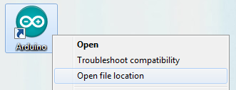](http://wiki.keyestudio.com/index.php/File:Libraries_1.png)

Step 2: Enter it to find out libraries folder which is the library file of Arduino.

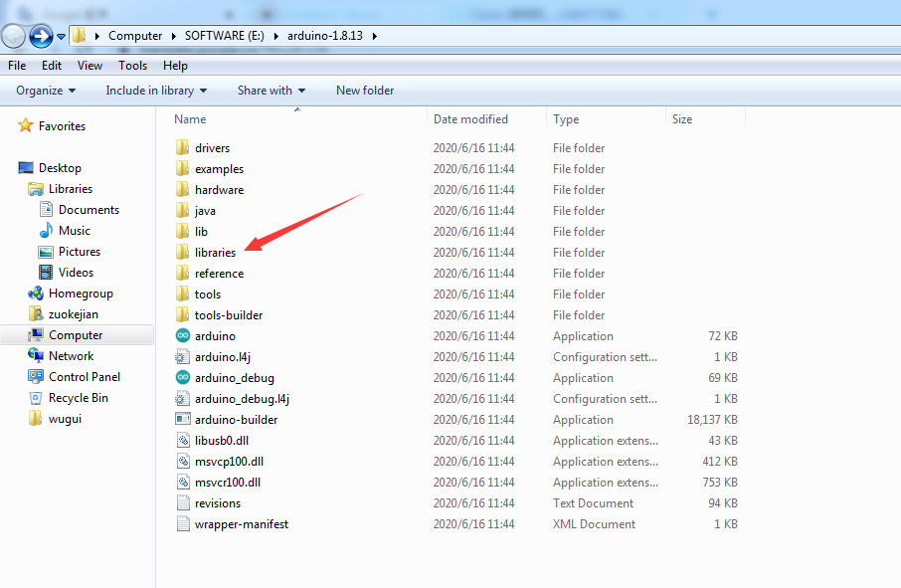

Step 3：Next to find out the“libraries”of tank robot(seen in the link: https://fs.keyestudio.com/KS0428), you just need to replicate and paste into the libraries folder of Arduino IDE.

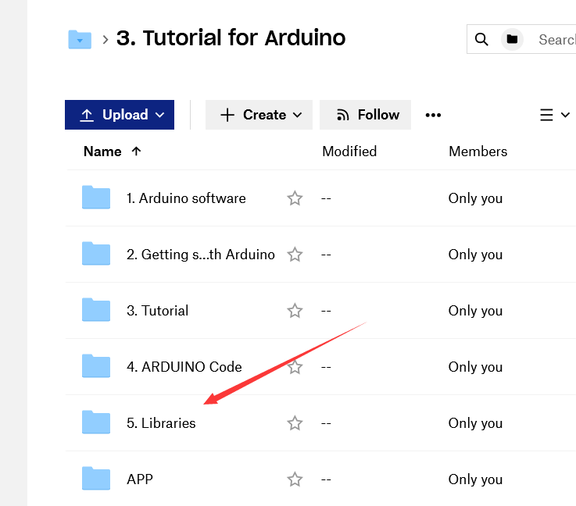

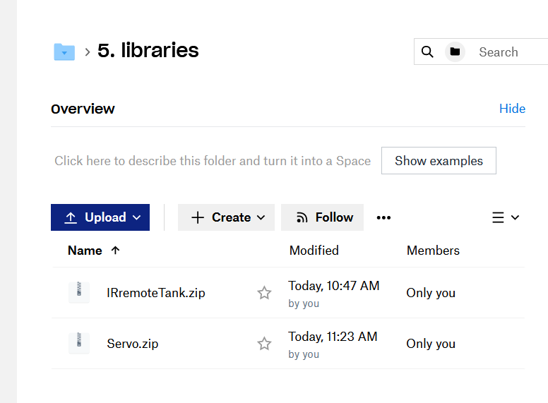

Download them from the link and unzip them.

Then add them into libraries of Arduino 1.8.13, as shown below:  
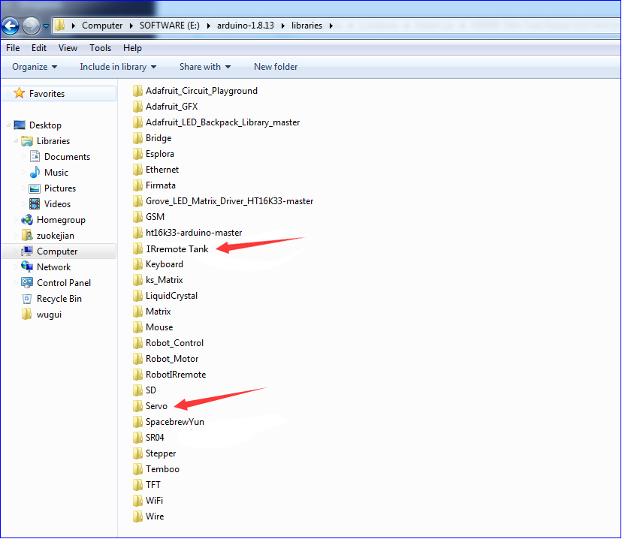

Now, you import libraries successfully.